**User Manual**

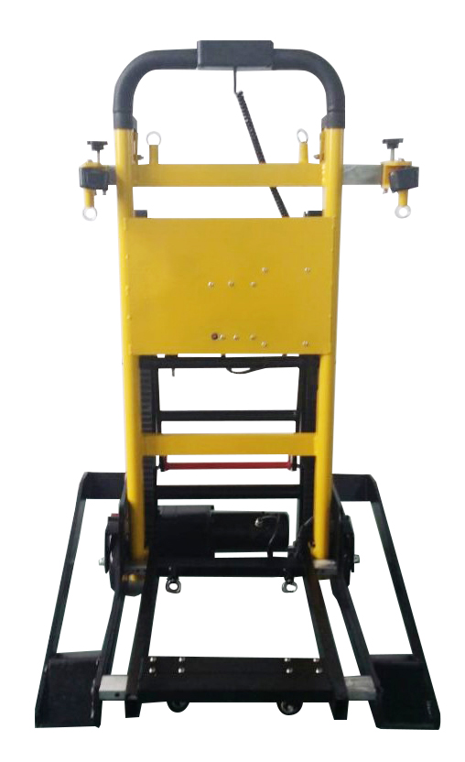

**Electric Stair Climbing Vehicle**

**Preparing the Stair Climbing Vehicle for use**

|  |  |
| --- | --- |
| Checking the battery charge   1. Either on the stair climbing vehicle or when it has been removed turns the battery key fully clockwise. 2. Depress the red button and the green lights will illuminate if there is charge within the battery.  * 1 light =25% charge * 2 lights= 50% charge * 3 lights= 75% charge * 4 lights= 100% charge | **[CRUSSE)(TU[)UNK4_QNLSC**  **B}FDDDR8{FPAP820~0N6S[8** |
| Charging the battery: on the stair climbing vehicle  3. Unscrew counter clockwise the battery connection cable. | QQ图片20161027084529_副本.jpg QQ图片20161027084525_副本.jpg |
| 1. Plug in the charger cable and charge the battery. 2. When battery is charged remove the charge cable and plug back in the connection cable and screw finger tight clockwise. | QQ图片20161027084521_副本.jpg QQ图片20161027084501_副本.jpg |
| Charging the battery: remove from stair climbing vehicle  6. Unscrew counter clockwise the battery connection cable. | QQ图片20161027084529_副本.jpg |
| 1. Pull down the front handle of the battery. 2. Turn the key fully clockwise and gently pull the battery forward to remove it. | QQ图片20161027084512_副本.jpg QQ图片20161027084517_副本.jpg |
| 1. Plug in the charger cable and charge the battery. 2. When battery is charged remove the charge cable and plug back in the connection cable and screw finger tight clockwise. | QQ图片20161027084536_副本.jpg |

|  |  |
| --- | --- |
| **Extending the operating handle**  **14. Turn the red knob clockwise and lift the handle up and allow it to lock in position. Depending on the height of the operator there are two heights that can be selected.** | QQ图片20161027084443_副本.jpg QQ图片20161027084439_副本.jpg QQ图片20161027084434_副本.jpg |
| **Extending the tracks**  **Push the lower bar with the red arrow forward in the direction of the arrow. This will release the locking mechanism for the tracks.** | QQ图片20161027084453_副本.jpg QQ图片20161027084450_副本.jpg |
| **15. Pull the upper bar of the tracks back until the tracks engage on the second locking position.** | QQ图片20161027084457_副本.jpg |
| **Applying the brakes**  **16. Depress the red flap of braking mechanism firmly with the foot to engage brake.** | QQ图片20161027084226_副本.jpg QQ图片20161027084219-1.jpg |
| **Slide adjustable**  **17. The under slide is adjustable to move right and left.**  **18. Finger gripped the buckle to pull outward.**  **19. Another hand to pull the slide outward or push inward to fit for the size of wheelchair.** | QQ图片20161027084238_副本.jpg QQ图片20161027084248_副本.jpg |
| **20. One finger of one hand grips the buckle to pull outward. Another hand to pull the top slide outward or push inward to fit for the size of wheelchair.** | QQ图片20161027084415_副本.jpgQQ图片20161206110910.jpg |
| **21. Adjust the lock catch to fit for the size of the wheelchair.**  **22. The lock catch can move right and left.** | QQ图片20161206110921.jpgQQ图片20161206110924.jpg |
| **23. Adjust the lock catch to grasp the stair climbing vehicle.** | QQ图片20161027084351_副本_副本.jpg QQ图片20161027084337_副本.jpg |
| **Motor Controls**  **24. Turn the key fully clockwise to turn on. A red light will illuminate on the front of the battery.** | QQ图片20161027084138_副本.jpg |
| **25.Turn the control buttons on by toggling the red switch**   1. **丨=On** 2. **O=Off**   **26.Press the yellow button to move the Stair Climbing Vehicle forward**  **27.Press the green button to move the Stair Climbing Vehicle backward**  **Using Additional Assistance**  **We advice that at least two operators are present when the Stair Climbing Vehicle is used for evacuating individuals over 100Kg.** | QQ图片20161027084131_副本.jpg |

**Cleaning**

Clean the stair climbing vehicle and its parts with a clean cloth or soft brush and warm soapy water. Rinse with warm water and air dry. Do not clean with products comprising of bleach or phenol. A stiff bristled brush can be used if necessary.

**WARNING**

Never leave an evacuee unattended in the Stair Climbing Vehicle and always use restraints.

**WARNING**

Avoid changing the position of the rapidly, as this may result in an injury to the evacuee. Support the stair climbing vehicle while adjusting handles.

**WARNING**

Improper maintenance can cause injury. Maintain the stair climbing vehicle only for the purpose described in this manual.